# | Elements to establish | Mid-Michigan LATTICE situation | Keypoint abstracted from LATTICE record | Fill-in your local facts
Core, central parts of LATTICE:
-
-
-
-
-
-

Additional parts of LATTICE:
-
-
-
-

Cautions (special care urged):
-
-
-
-

Value-added (spin-offs, extensions): -
-
-
-

The steps to take now (& lead times): -
-
-
-
-
-
-

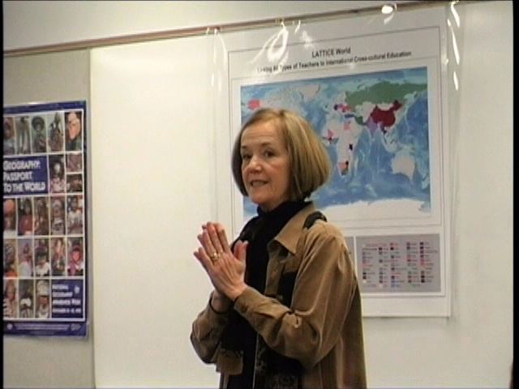  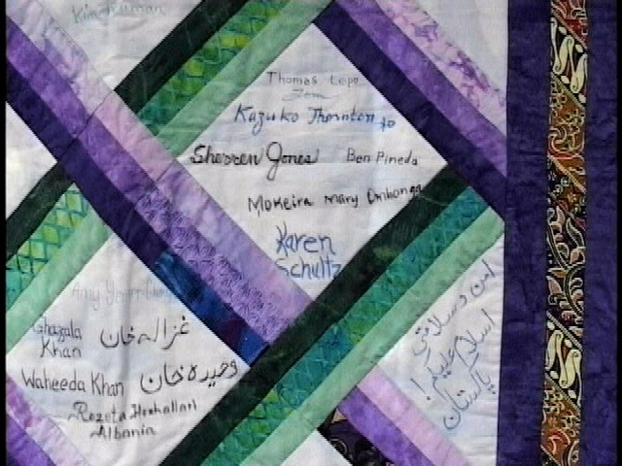 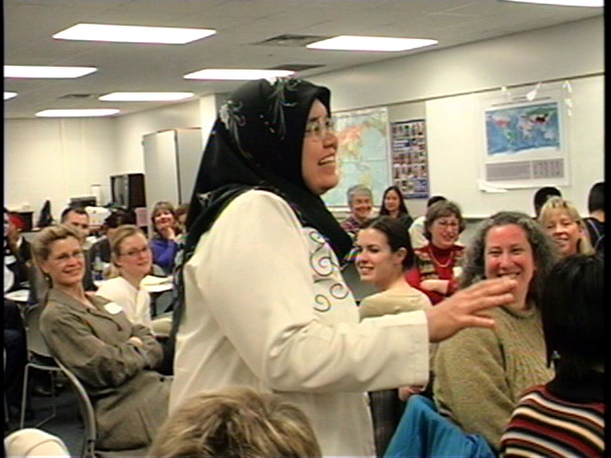 Welcome on the first day… dvd “making a L.A.T.T.I.C.E.”… literal lattice quilted & signed… personal perspective…
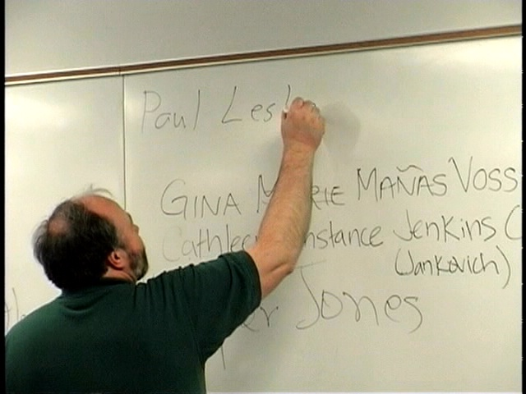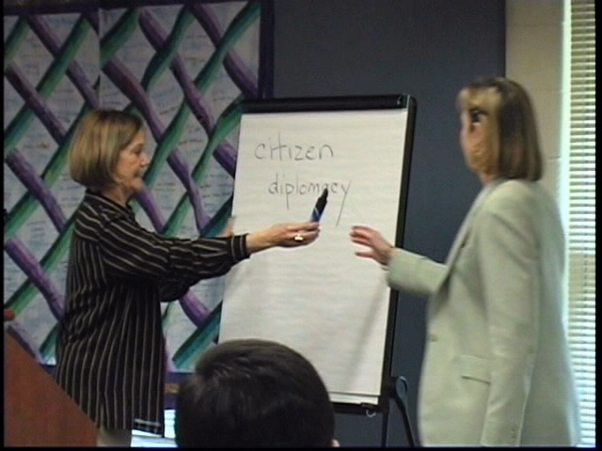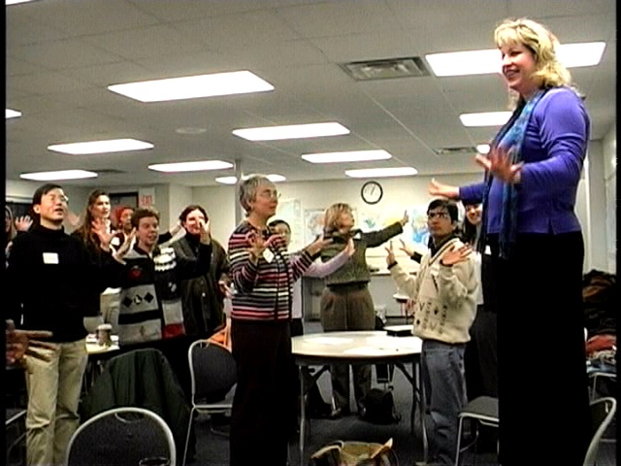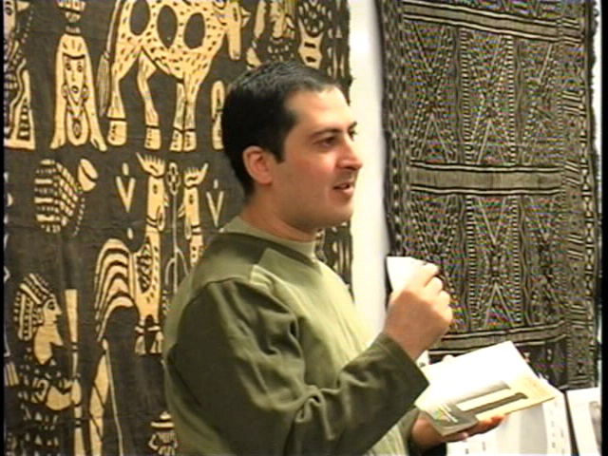
Significances of one’s names as cultural capsule: spelling, namesake, memories… leading by demonstration! Sharing short stories from Jordan
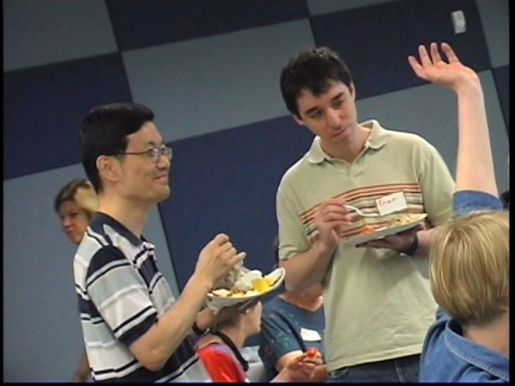 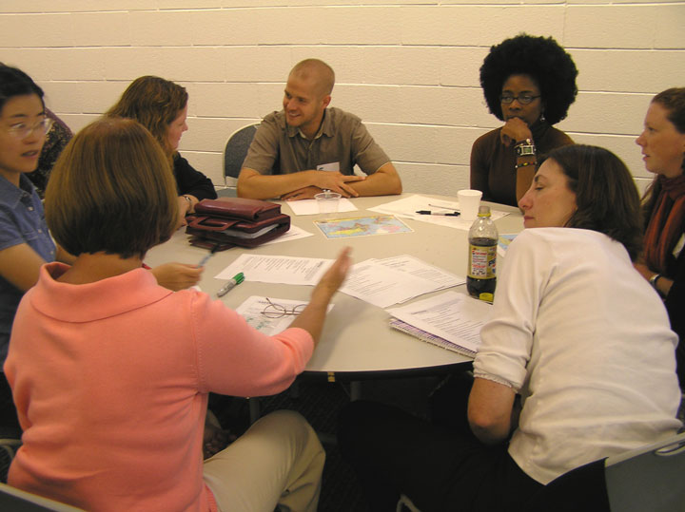 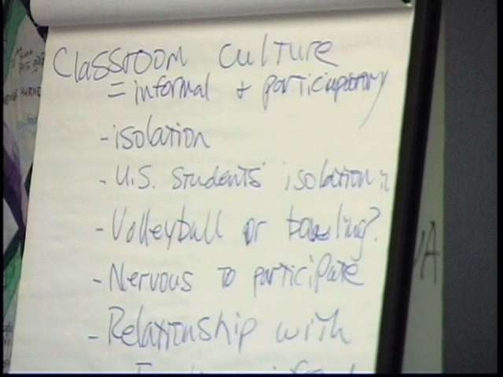
midway point food with stories… small group then shares to whole group flip chart on classroom cultures compare/contrast

